Household Address
Town/City | Click or tap here to enter text.
Postcode | Click or tap here to enter text.
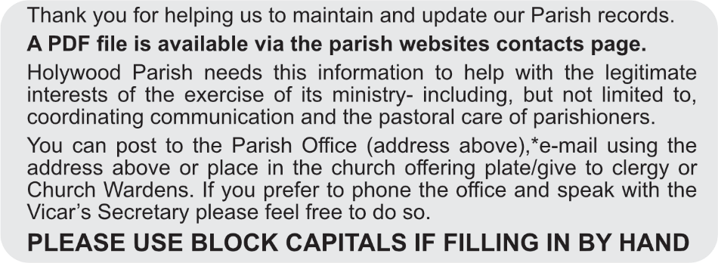

Please list below those living at this address who wish to be associated with Holywood Parish Church.
Please also inform us of anyone in, for example. nursing or residential care. Thank You

Surname | Christian Name/s | Preferred Title | Date of Birth | Phone Number | Email Address
Type Here | Type Here | Type | Type | Type Here | Type Here
Type Here | Type Here | Type | Type | Type Here | Type Here
Type Here | Type Here | Type | Type | Type Here | Type Here
Type Here | Type Here | Type | Type | Type Here | Type Here
Type Here | Type Here | Type | Type | Type Here | Type Here
Type Here | Type Here | Type | Type | Type Here | Type Here

Consent, Data Protection and Your Privacy (GDPR Compliance)
I hereby consent that Holywood Parish Church may retain the information given above ☐
Signature _____________________________ Date _______________

